ST. BERNADETTE August 19, 2018

The Deacon’s Bench
Deacon Jim Carper, Parish Life Director
The deacon’s bench, historically, is where the deacons sat during church services in the early protestant church. It seemed an appropriate title for this small section of our Church Bulletin; since it is an opportunity for me to share with you what’s going on in our Parish, from my point of view.
Something About Mary
I was sitting in a college theology class and the professor asked if anyone could explain the doctrine of the Assumption of Mary. A student replied, “yeah, that’s the teaching whereby the Catholic Church ‘assumes’ that Mary is in heaven.” In case you were wondering, that’s not the right answer. The Church does not just “assume” that any canonized saint in is in heaven. Rather, it authoritatively declares that a person is in glory and should therefore be honored in liturgy and imitated in life. Our church calendar is filled with saints’ days. But why a particular day for each saint? The first evidence for this goes back to AD 155, to a bishop named Polycarp. The account of his martyrdom notes that after his execution, the faithful collected his bones, more precious than gold, and put them in a place of honor where every year they gathered to celebrate the anniversary of his death as a sort of “birthday” into eternal life. Celebrating Mass in the catacombs over the relics of the martyrs’ led to the practice of putting relics in the main altar of every church. Eventually saints who did not die a martyr’s death were also commemorated on their heavenly “birthday” and their relics were accorded great honor.
The Bread of Life Discourse
Over the last two weeks and for the next two weeks Fr. Tom Welber’s Homilies have been covering Jesus’ “Bread of Life Discourse.” The Bread of Life Discourse is a portion of the teaching of Jesus which appears in the Gospel of John 6:22-59 and was delivered in the synagogue at Capernaum.
The title "Bread of Life" given to Jesus is based on this Biblical passage which is set in the Gospel of John shortly after Jesus feeds a crowd of 5000 people with five loaves of bread and two fish. After which He walks on the water to the western side of Sea of Galilee. The crowd follows by boat in search of Him.
John's Gospel, unlike the other three Gospels, does not include an account of the blessing of the bread during the Last Supper. This discourse has often been interpreted as communicating teachings regarding the Eucharist that have been very influential in the Christian tradition.
In the Christological context, the use of the Bread of Life title is similar to the Light of the World title in John 8:12 where Jesus states: "I am the light of the world: he who follows me shall not walk in darkness, but shall have the light of life." These assertions build on the Christological theme of John 5:26 where Jesus claims to possess life Just as the Father does and provide it to those who follow him.
Hope you are enjoying the homilies. You can find this one on You Tube at: https://www.youtube.com/watch?v=Cf3N-2f0YqQ

Last Sunday’s Collection….......................$7,530.00
Intentions for the Week
Saturday 5:30PM | +Elbert & Noella Martin
Sunday 8:00AM  10:00AM | Patricia McElderry  +Alice R. Stephens  Vickie Race
Monday 8:00AM | Intentions of All Parishioners  Intentions of All Parishioners
Tuesday 8:00AM | Intentions of All Parishioners
Wednesday 8:00AM | Intentions of All Parishioners
Thursday 8:00AM | +Anona Cookie Adams
Friday | NO MASS
August 19th
20th Sunday of Ordinary Time
First Reading -Proverbs 9:1-6
Psalm -34:2-3, 4-5, 6-7
Second Reading -Eph. 5:15-20
Gospel -John 6:51-58

August 26th
21st Sunday of Ordinary Time
First Reading -Joshua 24:1-2a, 15-17
Psalm -34:2-3, 16-17, 18-19, 20-21
Second Reading -Eph. 5:21-32
Gospel -John 6:60-69

PLEASE PRAY
Pray for the sick and the shut-ins and especially for those battling cancer. Lord, grant that all who are sick and shut-in find peace.

Have You Remembered St. Bernadette Catholic Church in Your Will or Trust?
Have you remembered your parish in your Will or Trust? For more information, please contact the Planned Giving Office at (213)637-7504 or email plannedgiving@la-archdiocese.org
Website www.ADLAegacy.org

Save the Date
Friday Sept. 21st

The Knight of Peter Claver Ladies Auxiliary Court #162 is hosting a spaghetti dinner in the hall at 5:30pm. Dinner includes: Spaghetti, garlic bread, salad and a beverage. There will also be a game of bingo.

Journey through Scripture – The Bible and The Sacraments - Preregistration
The Bible and the Sacraments is unlike any other study on the sacraments. It looks at the basic teaching of the Church as to their meaning and origin. But it goes further. It investigates the deeper mystery of the sacraments as illuminated by Sacred Scripture.
Examining the rich relationship between the Old and New Testaments, it reveals the sacraments as more than mere earthly rituals. They are incredible “‘powers that come forth’ from the Body of Christ” Class forming now! Please contact the office and provide us with your name, phone number and email address.
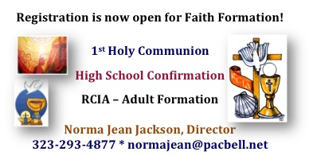
LOS ANGELES
_COFFEE HOUR

August
19th Mike Romo
26th Eric, Debora & Adam Griffin
September
2nd
9th
16th
23rd
30th Rachel’s Hope

We need ministries and/or parishioners to HELP sponsor doughnuts. Please call the rectory@ 323-293-4877 if you can assist. Thank you for your support!

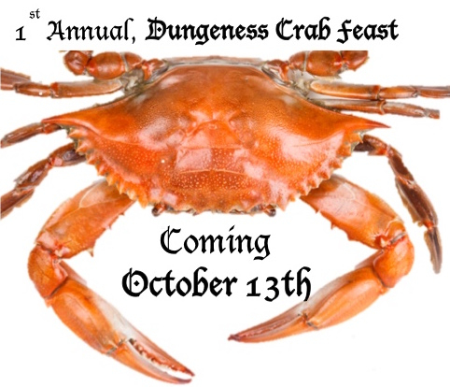
Did You Know?
​ Everyone has had an anxious moment or two in their lives, but many people — even kids — struggle with daily anxiety. Anxiety can be a contributing factor in depression, and even if it’s not that severe, it can make day-to-day activities tough. Kids who suffer from anxiety may exhibit physical symptoms like asthma and stomach aches, or could have trouble eating, sleeping, or going to the bathroom. If your child is showing signs of anxiety, it’s important to ask why, and then to help your child address the cause and manage the associated feelings.
ST BERNADETTE SPECIAL MONTHLY COLLECTIONS
1st Weekend: Christian Service collection
3rd Weekend: Debt-Reduction collection

