

Event | Baby Shower
Date | 6.23.18
Details | Sara to Pick-up at 8AM

Design Needs

Medium Arrangements | 2 | $125.00 each
Total |  | $250.00
Design Direction
Clean, Dutch-painting inspired vintage, less greenery more florals, blush, creams, rose golds, pale pinks, pastel purple

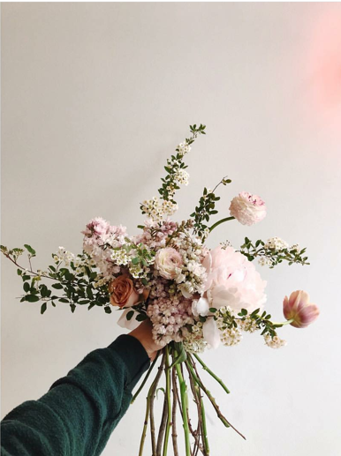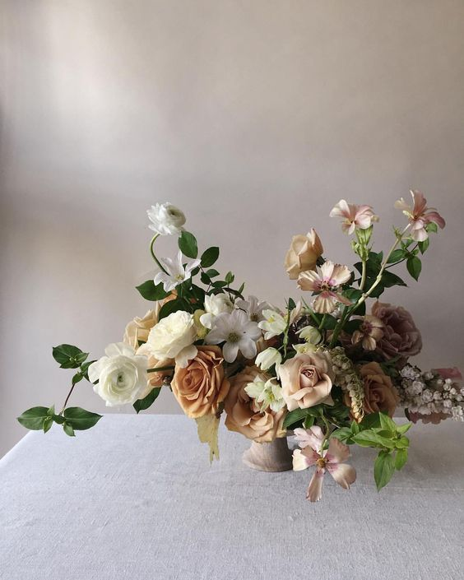

Next Steps

Payment accepted via Venmo (@ColleenMonroe) or check to Colleen Monroe: 227 W. California Blvd. #B, Pasadena, CA 91105.

Thank you! Looking forward to creating a beautiful day for you!

