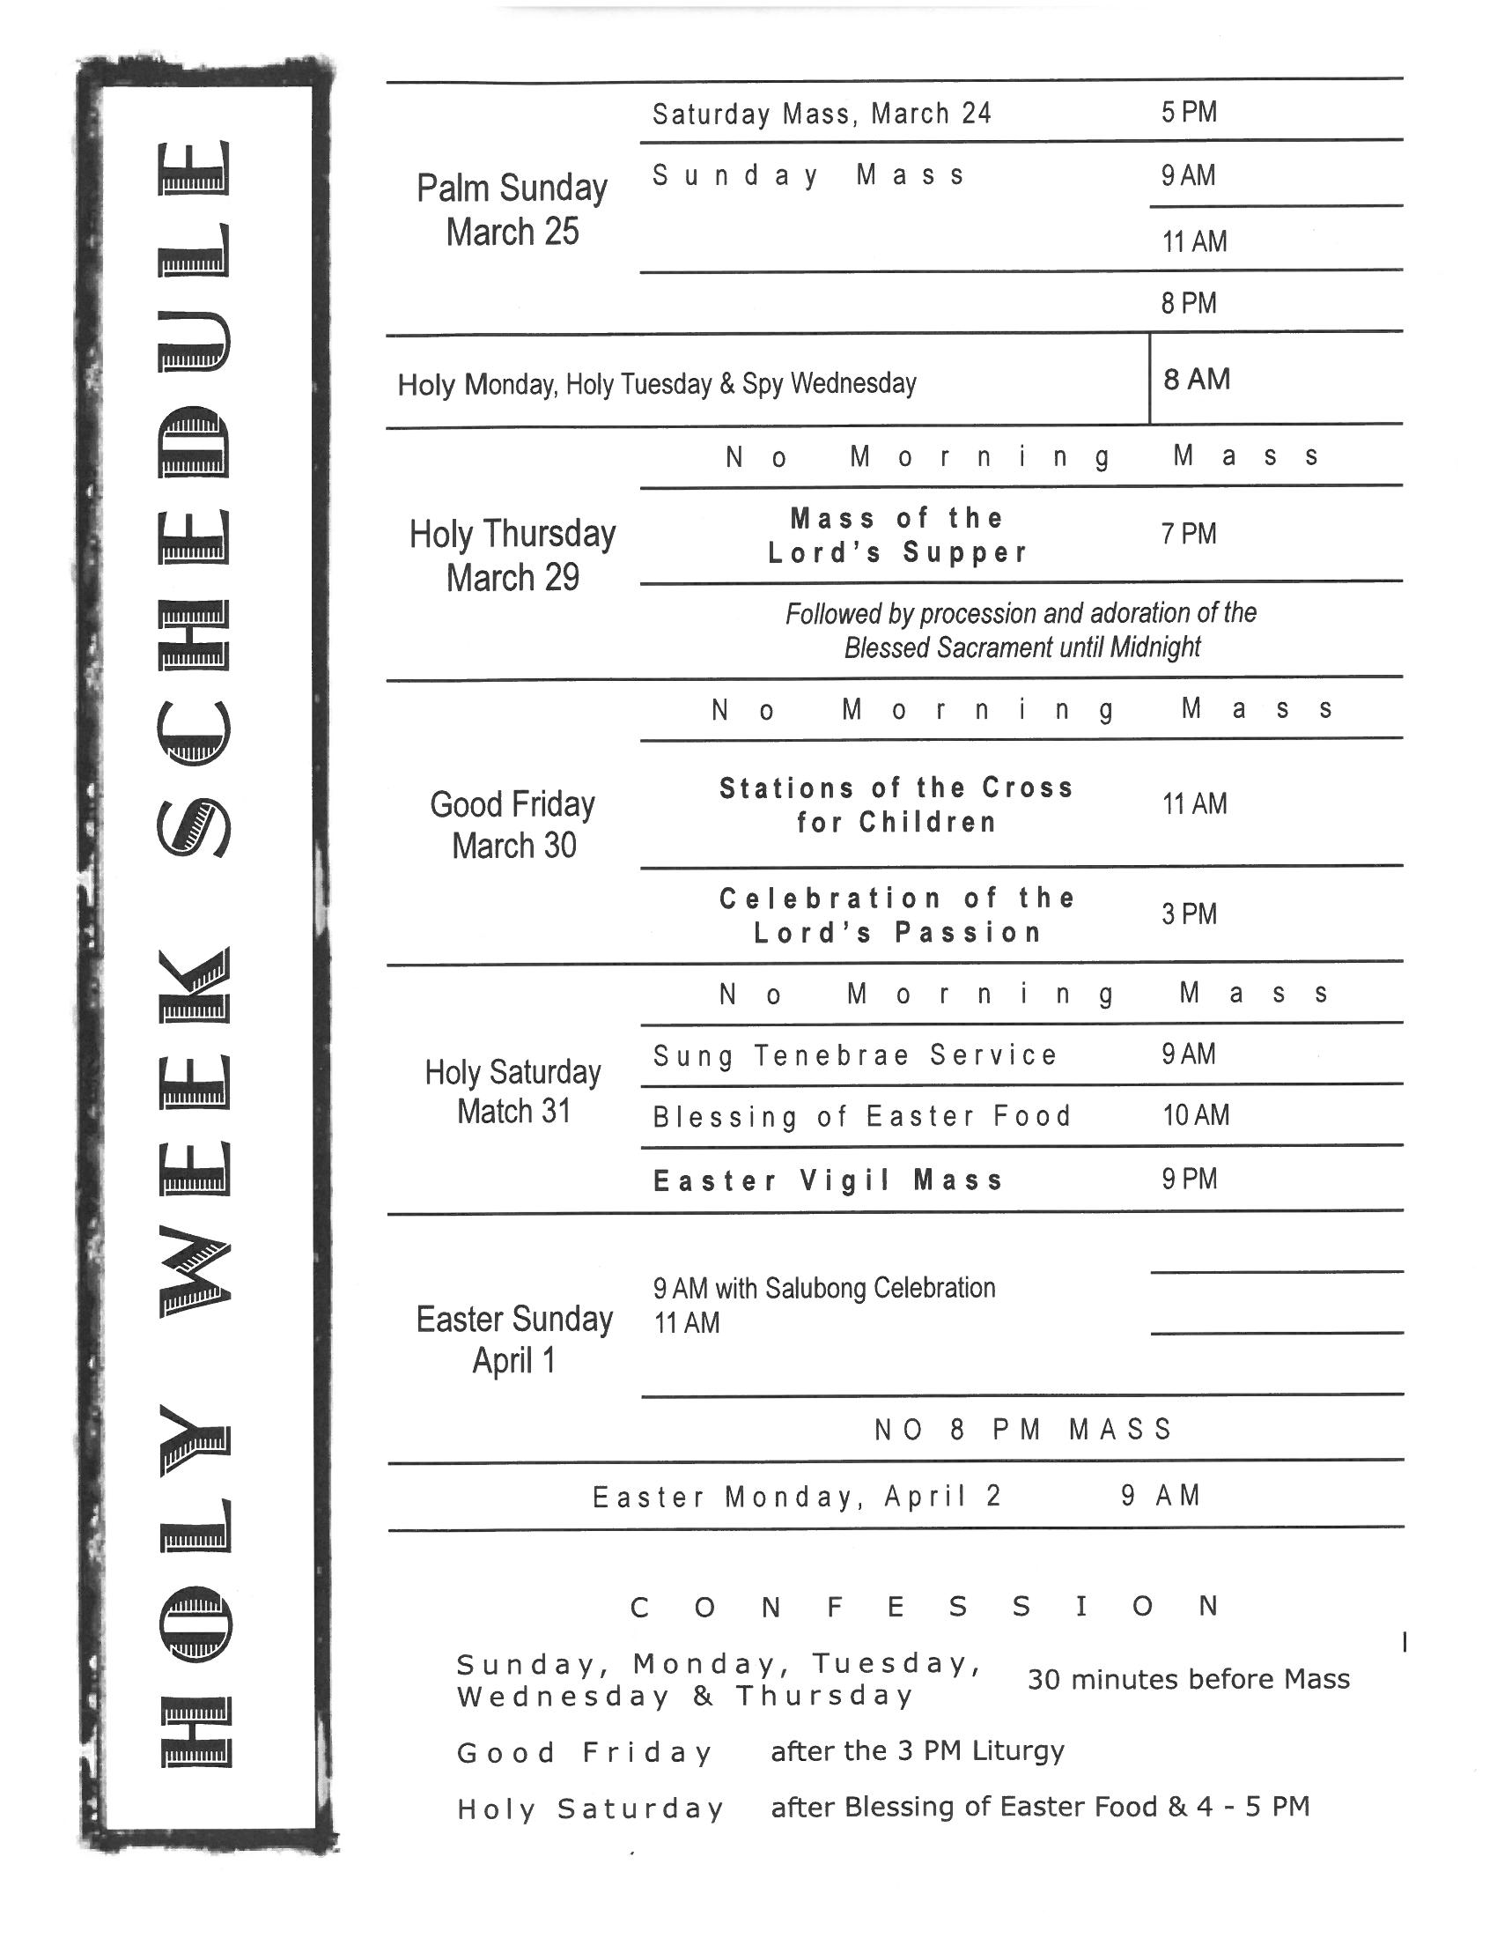
Saint Joseph’s Catholic Church
20676 Fraser Highway
Langley, BC V3A 4G5
Ph: 604-534-3303 Fax: 604-534-6458
Email: parish.sjl@rcav.org website: stjlangley.rcav.org
Fr. Lawrence Donnelly www.didobonaparte.wordpress.com

We celebrate today Passion (Palm) Sunday. You will find the readings for the mass on page 241 in the Blue missal in the pews.

Pastor: Fr. Lawrence Donnelly Secretary: Pat Wright
Assistant Pastor: Fr. Jude Onwana Bookkeeper: Trina Tang
Deacon: Dan Ritchie Catechism Coordinator: Kris Blair
Music Coordinator: Arthur Medina Youth Coordinator: Daniel Wack

Office Hours: 9:00 a.m. – 5:00 p.m. Mon – Fri Closed for Lunch: 12:30 – 1:30 p.m.

SACRAMENTS

SUNDAY MASSES WEEKDAY MASSES
Saturday 5:00 p.m. Monday to Friday: 8:00 a.m.
Sunday 9:00 a.m., 11:00 a.m., 8:00 p.m. Friday Evening 7:00.p.m.
Spanish Mass (1st Sunday of the Month) 5:30 p.m. Saturday and Holidays 9:00 a.m.
Children’s Liturgy of the Word during the 11:00 a.m. Mass

CONFESSIONS ADORATION OF THE BLESSED SACRAMENT
30 MINUTES PRIOR to Sunday Mass: Fridays 8:45 a.m. – 7:00 p.m.
8:30 AM,, 10:30 AM and 7:30 PM. Mon – Thurs. 8:45 a.m. – 10:00 a.m.
Saturday 4:00 – 5:00 p.m. and 30 minutes before the weekday Masses. Saturday 9:45 a.m. – 11:00 a.m.

MARRIAGES
Six months’ notice is normally required. Archdiocesan marriage preparation is mandatory.

BAPTISMS
Must attend the monthly Baptism Preparation Class. Call Parish office to register

WANT TO KNOW MORE ABOUT THE CATHOLIC CHURCH.
Contact: Adrian Fengler: faithjourney.saintjosephs@gmail.com

SCHOOLS:

ST. CATHERINE’S ELEMENTARY ST. JOSEPH’S PRESCHOOL
20244 – 32nd Avenue 20244 – 32nd Avenue
Langley, BC V2Z 2E1 Langley, BC V2Z 2E1
Phone: 604-534-6564 Phone: 604-530-4288
School Fax: 604-534-4871 www.stjosephschurchpreschool.com
Principal: Jeff Brophy
www.stcatherines.ca modonnell@stcatherines.ca

ST. JOHN BREBEUF REGIONAL SECONDARY HOLY CROSS REGIONAL SECONDARY
2747 Townline Road, Abbotsford, BC V2T 5E1 16193 – 88th Avenue, Surrey, BC V4N 1G3
1-604-855-0571 www.stjohnbrebeuf.ca 604-581-3023 www.holycross.bc.ca
Principal: Mr. Gianni Bittante Principal: Mr. Chris Blesch

ST. JOSEPH’S HOMESCHOOLERS’ CHOIR Contact:778-233-4049
MASS ANTIPHONS FOR PALM SUNDAY
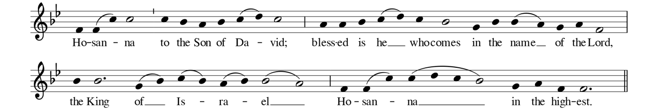
1-5. All glory, laud and honour To you, Redeemer King! To whom the lips of children Made sweet hosannas ring.  - You are the King of Israel  and David’s royal Son,  Now in the Lord’s name coming,  The King and Blessed One  - The company of angels  Is praising You on high;  And mortal, joined with all things  Created, make reply. | - The people of the Hebrews  With palms before You went;  Our praise and prayer and anthems  Before You we present.  - To You before Your passion  They sang their hymns of praise;  To You, now high exalted,  Our melody we raise.  - Their praises you accepted,  Accept the prayers we bring,  Great source of love and goodness,  Our Saviour and our King.
RESPONSORIAL PSALM ANTIPHON PSALM 22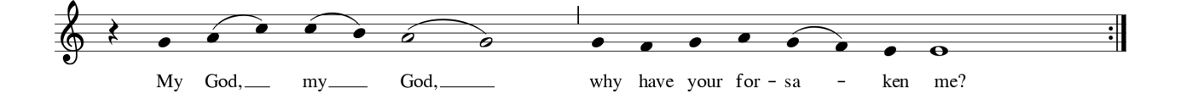
COMMUNION ANTIPHON Psalm 5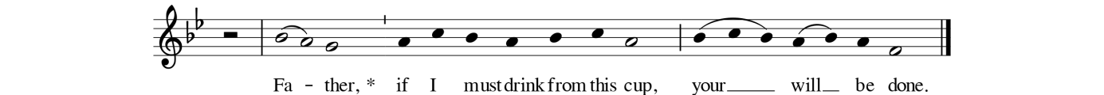

March 25, 2018

WELCOME TO ST. JOSEPH’S
Join us for Coffee and fellowship in the Parish hall after the 9 a.m. & 11 a.m. masses.

Baby Bottle Fund Raising: Drop your bottles at the Information Booth TODAY SUNDAY, MARCH 25

Spanish Mass for the month of April will be held 5:30 p.m. Sunday April 8. Mark your calendars!

Penitential Services:
Monday, March 26 7 p.m. Sts. Joachim & Ann Aldergrove.
Tuesday, March 27 7 pm St. Nicholas’ Langley

Chrism Mass: Wednesday March 28, 5:00 p.m. at Holy Rosary Cathedral. At this liturgy the Archbishop Blesses the Holy Oils used at Baptisms, Confirmations, Ordinations, and the Anointing of the Sick.

PARISH NEWS
Widows & Widowers of St. Joseph’s. The St. Elizabeth Group of Widows and Widowers is hosting a “Day of Recollection” for you. It will be held Wednesday April 4 from 8 am to 4 pm at The Little Flower Monastery in Deroche, BC. For more details call Moe Tremblay 604-530-3803
The Couples for Christ (CFC) is inviting you to attend the Christian Life Program, an integrated course that leads into a renewed understanding of God and a Spirit-filled Christian life. This 12 week program will be held at the St. Joseph Parish Hall, starting April 7, 2018 (Saturday) from 1:30 - 4:00pm.

Estate & Memorial Planning Workshop: Presentation by the Archdiocese of Vancouver Catholic Cemeteries. Tuesday April 17, 7:00 pm in the parish hall. Let us help you deal with matters you may not have thought about before; gather your thoughts before you write your Will or prepare to update your Will. Learn about how to donate to the Church in your Will. Learn about the beauty of the funeral rites and how to formulate Pre-Need arrangements. There will be FREE guides and loads of practical advice. No investment services or insurance promoted or sold. Please register at rccav.org/events so that we know how many kits we need to prepare.

HOLY LAND PILGRIMAGE INFO NIGHT: Meet the tour director and hear about the upcoming January 2019 "Walking in the Footsteps of Jesus" Holy Land Pilgrimage with Fr. Lawrence Donnelly and St. Joseph's Parish in Langley. There will be a short presentation with Q & A. Join us in the parish hall after the 5 pm Mass at St. Joseph's on Saturday, April 21. For questions please contact: John or Natalie/www.oc-travel.com/info@oc-travel.com/ 1-800-675-9088.

Second Quarter, a group for those in their "second quarter" (after undergraduate, before middle age!). For more info, Facebook group or email David at sj2ndquarter@gmail.com

Volunteer Administrative Assistant: The Prison Ministry requires an administration support person who will assist in promotional events, screening of persons interested in volunteering for prison work, scheduling of volunteers and other administrative duties. This does not involve going into the prisons. Please contact Don Adams at adamsmgmt@shaw.ca or at 604 534-6060.

YOUTH EVENTS

Life Teen: Thinkfast Retreat - Gr 8-12
If you're in grade 8-12 plan to come out to our Thinkfast retreat which is taking place from Good Friday - Holy Saturday @ St Joe's! Registration deadline is Tuesday! For more details, or to register, email: saintjosephs.youthmin@gmail.com

Learn more and sign up for updates at stjlangley.rcav.org/youth

SCHOOLS

St. Catherine's School- Walkathon:
Students will be collecting pledges after masses April 14/15. Please help support this fundraiser. Students will be walking 5/10km on April 20 to support their school. Thank you

Save The Date: It’s St. John Brebeuf High School's Silver Anniversary! Come and celebrate 25 years of Catholic education in the Fraser Valley at our Gala Dinner and Dance on Saturday, April 28, 2018. Tickets will go on sale mid-March. For more information, please contact office@stjohnbrebeuf.ca.

St. John Paul II Academy is happy to announce they are continuing to accept applicants for Gr. 8 for the 2018-19 school year. As there are a limited number of spaces available, all student applications must be completed and returned to Mr. Michel DesLauriers, Principal, 4885 St. John Paul II Way, Vancouver, BC, V5Z 0G3.
You can find the Application Form and more information about tuition and financial assistance on the school website: www.sjp2academy.com/admissions/
E: mdeslauriers@cisva.bc.ca
T: 604. 683. 9331
OTHER NEWS

Helpline Volunteer Training by Domestic Abuse Services – Our Lady of Good Counsel Society: You can make a difference in the lives of victims of abuse. Join us for our spring training.
Fridays: April 6, 13 & 20 from 6:30 pm – 9:30 pm and Saturdays, April 7, 14, & 21 from 9:00 am to 3:00 pm at Holy Trinity Parish, North Vancouver. Call 604.585.6688 to register or for more information.

Retrouvaille ( A Lifeline for Marriages) helps married couples get back to a loving relationship, providing the tools you need to get your marriage back on track. For confidential information or to register for the program at the beautiful Barnabas Landing on Keats Island on the weekend of April 13 - 15, 2018, call Marc and Candice at 604-530-6710, email us vancouverbc@retrouvaille.org or visit our website www.retrouvaillevancouver.com

Worldwide Marriage Encounter Weekend
April 28-29, JPII Pastoral Centre (Non-residential) Marriage Encounter is designed to deepen and enrich the joys a couple shares together whether they have been married a short time or many years. For more information or to register, contact; Steve & Mary Bohnen – 604 876-7298 or wwmevancouverbc@gmail.com or wwme.org

