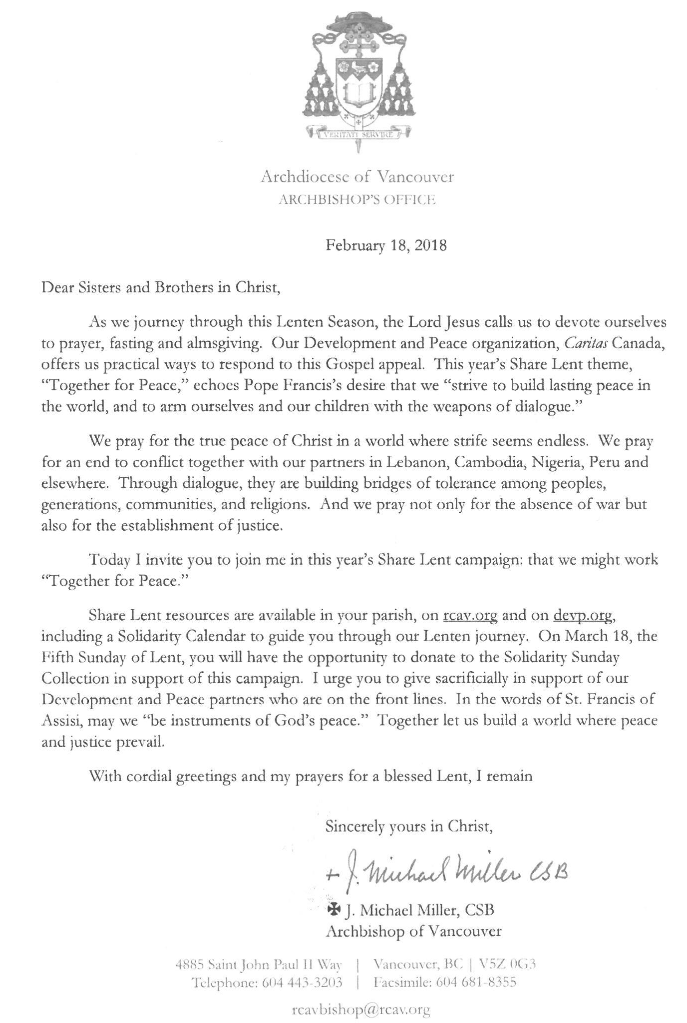Saint Joseph’s Catholic Church
20676 Fraser Highway
Langley, BC V3A 4G5
Ph: 604-534-3303 Fax: 604-534-6458
Email: parish.sjl@rcav.org website: stjlangley.rcav.org
Fr. Lawrence Donnelly www.didobonaparte.wordpress.com

We celebrate today the 2nd Sunday of Lent. You will find the readings for the mass on page 190 in the Blue missal in the pews.

Pastor: Fr. Lawrence Donnelly Secretary: Pat Wright
Assistant Pastor: Fr. Jude Onwana Bookkeeper: Trina Tang
Deacon: Dan Ritchie Catechism Coordinator: Kris Blair
Music Coordinator: Arthur Medina Youth Coordinator: Daniel Wack

Office Hours: 9:00 a.m. – 5:00 p.m. Mon – Fri Closed for Lunch: 12:30 – 1:30 p.m.

SACRAMENTS

SUNDAY MASSES WEEKDAY MASSES
Saturday 5:00 p.m. Monday to Friday: 8:00 a.m.
Sunday 9:00 a.m., 11:00 a.m., 8:00 p.m. Friday Evening 7:00.p.m.
Spanish Mass (1st Sunday of the Month) 5:30 p.m. Saturday and Holidays 9:00 a.m.
Children’s Liturgy of the Word during the 11:00 a.m. Mass

CONFESSIONS ADORATION OF THE BLESSED SACRAMENT
30 MINUTES PRIOR to Sunday Mass: Fridays 8:45 a.m. – 7:00 p.m.
8:30 AM,, 10:30 AM and 7:30 PM. Mon – Thurs. 8:45 a.m. – 10:00 a.m.
Saturday 4:00 – 5:00 p.m. and 30 minutes before the weekday Masses. Saturday 9:45 a.m. – 11:00 a.m.

MARRIAGES
Six months’ notice is normally required. Archdiocesan marriage preparation is mandatory.

BAPTISMS
Must attend the monthly Baptism Preparation Class. Call Parish office to register

WANT TO KNOW MORE ABOUT THE CATHOLIC CHURCH.
Contact: Adrian Fengler: faithjourney.saintjosephs@gmail.com

SCHOOLS:

ST. CATHERINE’S ELEMENTARY ST. JOSEPH’S PRESCHOOL
20244 – 32nd Avenue 20244 – 32nd Avenue
Langley, BC V2Z 2E1 Langley, BC V2Z 2E1
Phone: 604-534-6564 Phone: 604-530-4288
School Fax: 604-534-4871 www.stjosephschurchpreschool.com
Principal: Jeff Brophy
www.stcatherines.ca modonnell@stcatherines.ca

ST. JOHN BREBEUF REGIONAL SECONDARY HOLY CROSS REGIONAL SECONDARY
2747 Townline Road, Abbotsford, BC V2T 5E1 16193 – 88th Avenue, Surrey, BC V4N 1G3
1-604-855-0571 www.stjohnbrebeuf.ca 604-581-3023 www.holycross.bc.ca
Principal: Mr. Gianni Bittante Principal: Mr. Chris Blesch

ST. JOSEPH’S HOMESCHOOLERS’ CHOIR Contact: 778-233-4049

MASS ANTIPHONS FOR THE SECOND SUNDAY IN LENT YEAR B
ENTRANCE ANTIPHON Isaiah 58.9 Psalm 91
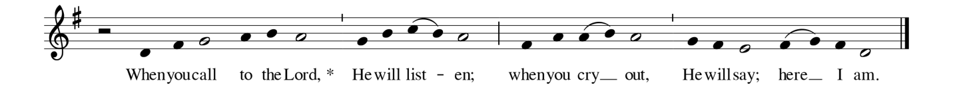
RESPONSORIAL PSALM ANTIPHON Psalm 116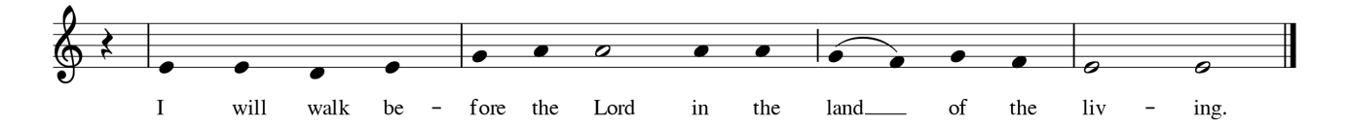
COMMUNION ANTIPHON Psalm 5
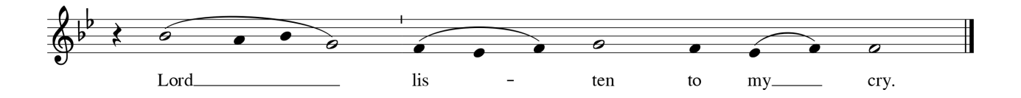

February 25, 2018

WELCOME TO ST. JOSEPH’S
Join us for Coffee & Fellowship in the Parish hall after the 9 a.m. & 11 a.m. masses.

PARISH ACTIVITIES

Bible Study at St Joseph's:

Gospel According to John
Come and join us for the study of John's Gospel. Thursdays 7 PM at St Catherine's School OR Saturdays 10 AM in
the Parish Hall.

Serra Club Way of the Cross: Friday March 2, 6:30 p.m. followed by mass. Come and pray for vocations to the priesthood and religious life. Browse at the Serra Club display table.

First Friday Sacred Heart Novena Mass March 2 , 7:00 p.m. Fellowship after mass sponsored by Knights of Columbus.

PARISH NEWS

Recently Baptized: Madeleine Pandyra, Renjay Peralta, Ryland Pham.

Welcome to the Parish: Nagui & Miguel Fuentes, Vicente Juarez, Dorothy Nash, Consorcia Salvador & Anus Saludes, Shimy & Jimson Varghese.

R.I.P.Please pray for the repose of the soul of Margaretha (Martha) Degroot.

Hope for Women Pregnancy Services: (formerly Langley Pro-Life) Baby Bottle Campaign Fund Raiser will take place Feb.24 & 25 in the back of Church on Saturday, in Hall Sunday morning. Take a bottle home. Fill it with change, cash or cheques. Return your bottle to the parish.

Migrant Workers Dinner: Volunteers are needed to help in the kitchen for the Migrant dinner on the First Sunday of the Month from 5:30 – 8:30 p.m. Our ministry has grown in the past few years since it started. We now serve close to 200 people. Please call Debbie Clendening 604-533-9175 if you are able to help. It will be greatly appreciated.

Second Quarter, a group for those in their "second quarter" (after undergraduate, before middle age!). Come along for karaoke at K-POP in Surrey, 7pm Saturday 3 March! We want to reach a quorum of at least 10 to keep the cost reasonable (~$10-15 each), so if you're planning to come, please confirm on the Facebook group or email David at sj2ndquarter@gmail.com

St. Elizabeth Group: (for widow/widowers) next meeting Saturday March 10, 2 p.m. in the parish hall. All widow/widowers of our parish are invited. Please contact Moe Tremblay 604-530-3803 or just attend.

YOUTH EVENTS

Edge: Fruit - Gr 6/7
Our next Edge night is March 16th! 7 – 9 pm. If you're in grade 6 or 7 make sure you save the date!!
Life Teen: The Word - Gr 8-12
February 25th is our next Life Night!! It's going to be focused around the Bible and how we can build relationship with Jesus by reading it! Come out from 6-8pm in the parish hall!!

FREEDOM - Gr 8-12
March 9th the Archdiocese is hosting its annual Freedom event!! Freedom is a fantastic event with opportunities to hear the Archbishop speak, to go to confession, have NET lead music, and to experience the greater community of Catholic youth in the Diocese!! This year Freedom is being held at St Nicholas in Walnut Grove from 7pm - 10:30pm, Friday, March 9th! You won't want to miss this fantastic event!!

Learn more and sign up for updates at stjlangley.rcav.org/youth

SCHOOLS

Save The Date: It’s St. John Brebeuf High School's Silver Anniversary! Come and celebrate 25 years of Catholic education in the Fraser Valley at our Gala Dinner and Dance on Saturday, April 28, 2018. Tickets will go on sale mid-March. For more information, please contact office@stjohnbrebeuf.ca.

Holy Cross High School Spring Break Basketball Skills Camp: for ​ Boys and Girls in Gr. 4-7. ​ Tues. March 12​th​ – Fri. March 16​th​ Each Day 9am-12pm at HC High School Gym - email Head Coach/Teacher Matthew LeChasseur ​hcboysbasketball@gmail.com limited space and first come first serve. Download and fill out a registration form at ​www.holycross.bc.ca​ or www.hcboysbasketball.com​ and bring a cheque and form on the first day of the camp. Cost:$120 includes t-shirt, daily prizes and snack. Come improve overall basketball skills, meet future classmates and have fun.

Holy Cross High School Volleyball Camp: Junior Crusader Volleyball program is geared for girls currently in grades 4&5 who want to increase their volleyball skills and love of the game. For some players, this will be their first introduction to the sport so there will be a large focus on fun while learning new skills. This is a great opportunity to have fun, make new friends and learn the game. Cost is $80. Program runs every Saturday 9:30-11:00 April 7-June 9 @ Holy Cross Regional High School. If you are interested: email bgrandia@holycross.bc.ca to secure a spot before March 9.

OTHER NEWS

Domestic Abuse Services - Our Lady of Good Counsel Society 22nd Annual General Meeting – Wednesday, March 7th,at 7 pm at St. Michael’s Parish Center, Burnaby, BC . We are pleased to have two members of the Vancouver Police Domestic Violence Unit speaking at our meeting. Bring a friend to learn about the Society and the good work we do. Interested in joining our Board of Directors and making a difference in
peoples’ lives? Call Della at 604.585.6688 for more info.

Retrouvaille ( A Lifeline for Marriages) helps married couples get back to a loving relationship, providing the tools you need to get your marriage back on track. For confidential information or to register for the program at the beautiful Barnabas Landing on Keats Island on the weekend of April 13 - 15, 2018, call Marc and Candice at 604-530-6710, email us vancouverbc@retrouvaille.org or visit our website www.retrouvaillevancouver.com For more information about the venue, please visit www.barnabasfm.org

Worldwide Marriage Encounter Weekend
April 28-29, JPII Pastoral Centre (Non-residential) Marriage Encounter is designed to deepen and enrich the joys a couple shares together whether they have been married a short time or many years. Married couples learn how to rekindle the passion in their relationship and how to keep their love growing year after year. Don’t wait to invest in your marriage. For more information or to register, contact; Steve & Mary Bohnen – 604 876-7298 or wwmevancouverbc@gmail.com or wwme.org

